Ryan Woodward

V00857268

SENG 310

Assignment 1

**Analyzing Spotify**

**Part 1:**

1. The high level conceptual model is based more so around an office desk as opposed to the physical action of selecting and playing music.

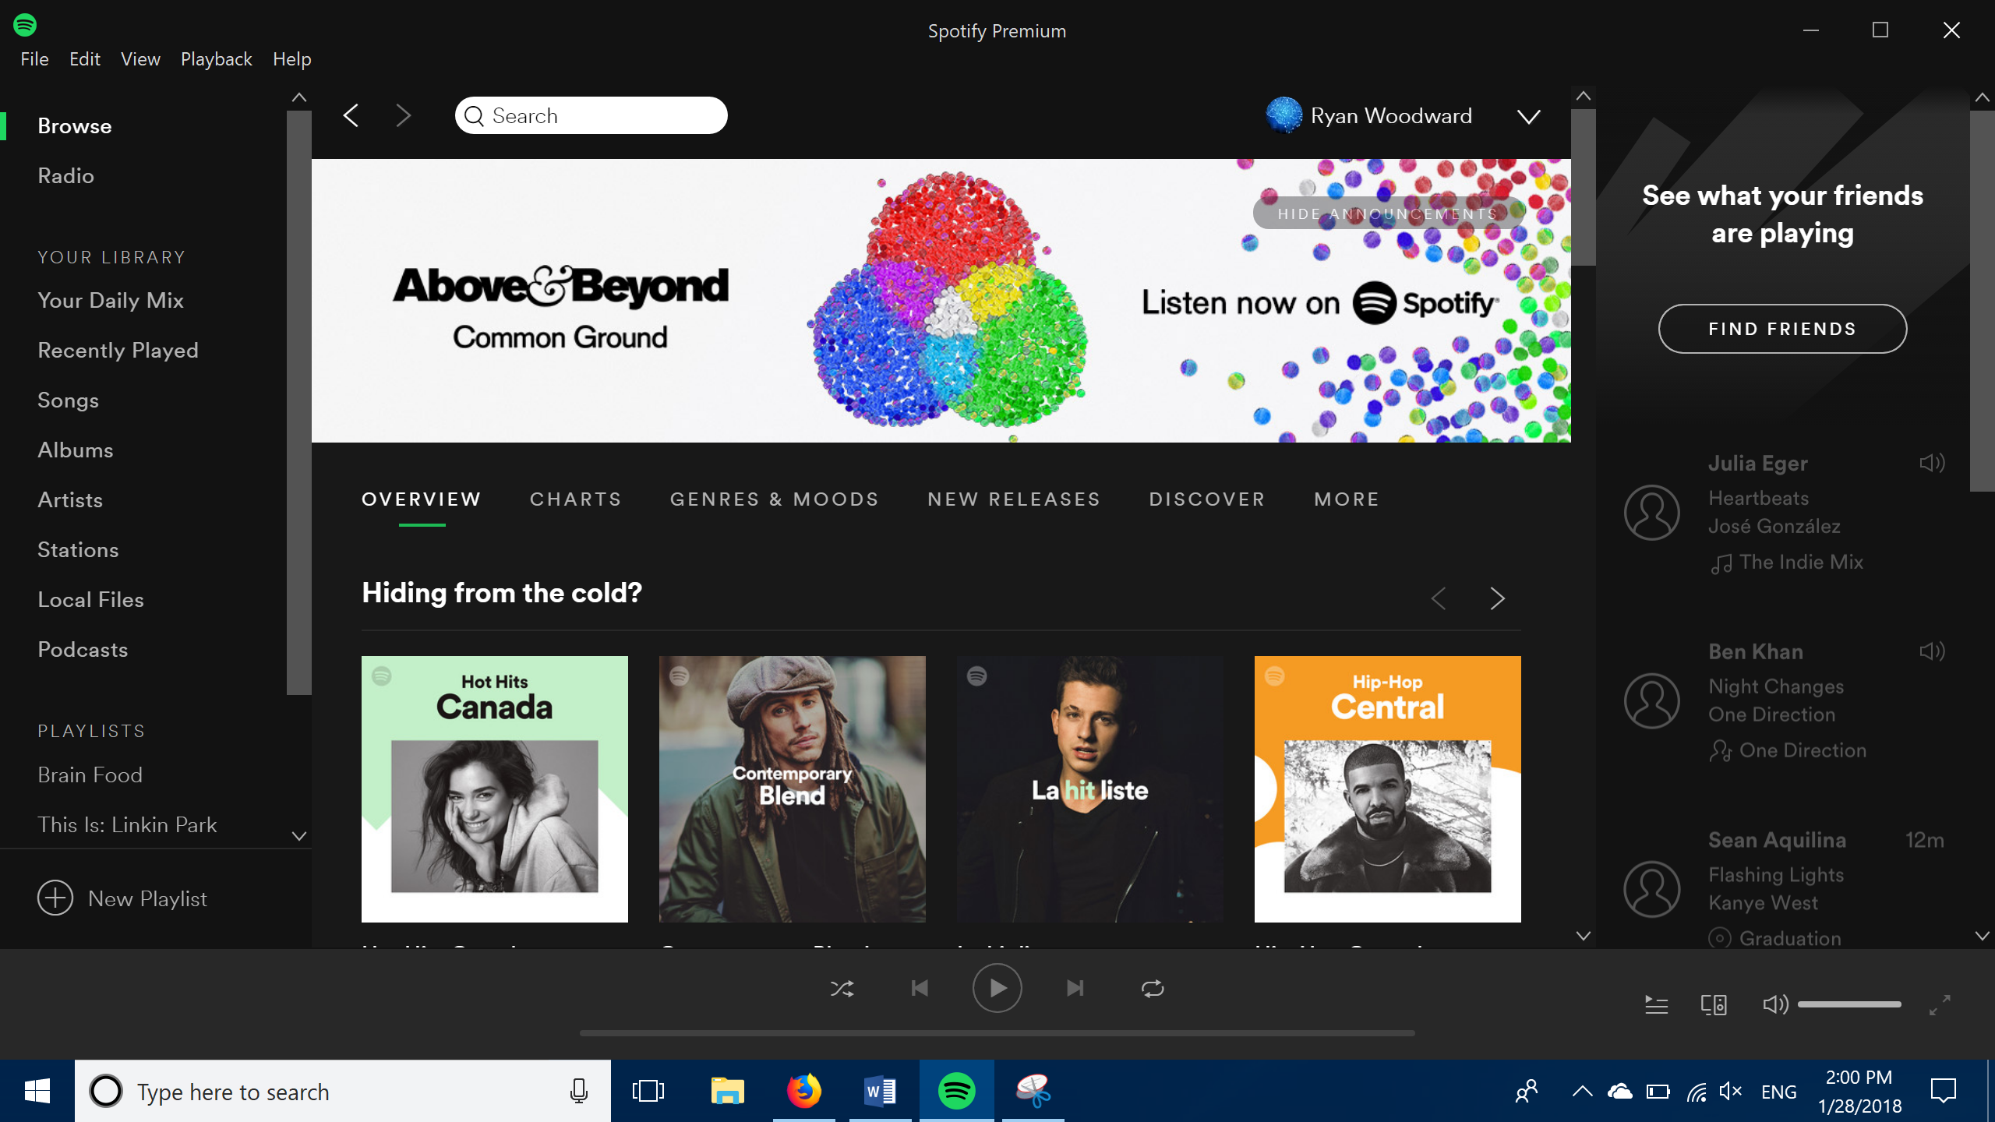

This is initial home screen that is offered to you when you first open up the spotify windows 10 application. If this conceptual model where being designed around the actual physical act of selecting music you would expect a drag and drop action similar to the physical action of placing a record or cd into the stereo. This conceptual model is based more around a dynamic office space. The left side bar contains your personal library and allows you to look at what you’ve already listened to, and the right side bar contains the social aspect that allows you to connect with your friends. The bottom task bar contains the actual music controls for what you want to listen to.

1. Some key metaphors and analogies used.
   1. Your daily mix
      1. This metaphor provides the user with a curated playlist based upon what the user has already listened to. The playlist is dynamic and will change on a day to day basis depending on what music has already listened to. The term daily mix has simple discoverability and with one click a playlist is created for you
   2. Playlist
      1. This metaphor has become synonymous with media. It is a list of songs that you are able to create yourself and play.
   3. Radio
      1. Will create some music for you to simulate listening to the radio. Essentially you just a station and a playlist is created.
2. Main task domain objects
   1. Playlists
      1. Attributes are add to library, play now, go to a quick options menu, or click on the picture to go to a deeper options menu
   2. Genres
      1. Attributes consist of additional playlists, artists, and albums
   3. Search
3. Each conceptual model object acts like the branches of several rooted trees. If were to look for a genre, that genre would consist of artists, albums, and curated playlists. From there you can follow any of these artists, albums, or playlists.
4. Operations available

**Part 2:**

1. It is quite easy to determine the function of the system. The main point of Spotify is to answer stage one of Norman’s design principles, which is forming a goal. The goal here is to either listen to your library of music, or listen to new music. Spotify allows you to play your own music by using the sidebar to access your own music. It also allows you to discover new music by using the main page, which uses large colourful icons, to advertise new music which is curated based upon your continual usage and listening history.
2. It is quite easy to tell what actions are possible by simply hovering your mouse over the musical playlist albums presented. The icons will grey out and present you with recognizable symbols. The + symbol will add it to your collection, and the > button will play the music. 3 dots will give you more quick options, and clicking on the box itself will take you to a more detailed page.
3. Determining the action from intention to physical movement is quite simple as well. My intention is to discover and listen to new music similar to music I already like. In order to achieve this intention I need a page that can suggest new music for me. In spotify this is the main page that opens when you first open the application. On this main page it lists suggested playlists based upon your listening history, from here in order to execute the action you simply hover over the suggested option and are able to easily recognizable symbols to play or follow these playlists.
4. The actions are easily performed by clicking on the symbols that are represented.
5. The desired state of the system is listed in the bottom tool bar that is always present on the page. Each icon is clickable and is easily discoverable.
6. The system state is easily discoverable by the main side bar on the left side of the app. The state that Spotify is in is representing by bolding the folder and placing a green bar next to it. The green bar differentiates between simply hovering your mouse over a different state that you want to get to, which will bold the option.
7. I would say that Spotify suffers from the gulf of evaluation. Although the side tool bars are well laid out in terms of discoverability and learnability it’s once you start getting in depth into their folders where the state of what’s going on get’s a little confusing. For example, on the bottom toolbar there is a speaker option which will allow you to select any speaker on any device to use as the base speaker from which Spotify on your profile has played before. The initial settings for the speakers I want to use won’t align. For example I have spotify open on my computer and my phone at the same time. All of a sudden if I hit play on my phone it won’t simply play through my phone, it will start changing the options on the computer. If I am playing spotify on my phone, but have the speakers running through my playstation 4 there is also a significant issue. If I swipe through an album to search for another song it will automatically change the song on the ps4. So there is no way for me to be able to search that album without changing the song on the console. This presents a pretty disjointed experience on something as simple as searching for another song.

**Part 3:**

1. Overall I feel like the conceptual model is quite good for spotify. It keeps the left toolbar as the basis on all the concepts that are applicable. Browsing for new music, searching your library for artists, songs, albums, podcasts. Any initial goal is kept on the left toolbar and then the main page will list icons related to your goal. I can be add music to my library, or listen to new music in as little as one click from the app initially opening
2. The product does offer good discoverability. From hovering your mouse over icons it offers recognizable symbols with feedback. Not only that if you are unaware of what a symbol does, if you keep your mouse over the symbol a dialog box will pop up and explain to you what that symbol means.
3. Spotify makes use of the left toolbar as the basis for most of its mappings. If the initial goal is to browse new music you simply have to have the browse function highlighted and the main central page will list recommended playlists, but will also list several other options if my intention is to continue to browse. From here it is as simple as hovering your mouse over an icon and more options will be presented to you. Whether this be to add to your own library or play immediately the symbols presented are quite intuitive.
4. The feedback given is by highlighting any symbol that you use and in the case of navigating toolbars a green bar is given to indicate which bar you are currently on.
5. The signifiers Spotify uses are of crucial importance. The two main signifiers that it uses are the + symbol and the > symbol. The + symbol answers the simple question of how do I add this song/playlist/artist/album to my library, and offers you the affordance to do so. The > button will immediately play whatever playlist/song/artist/album that you are currently hovered over, offering the affordance of listening to music quickly.